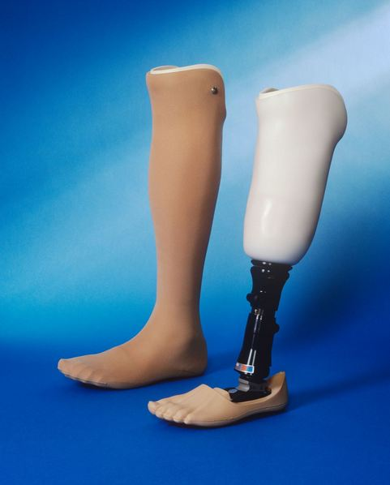


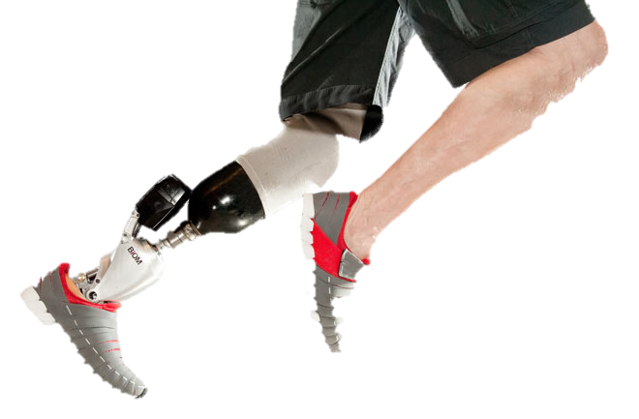

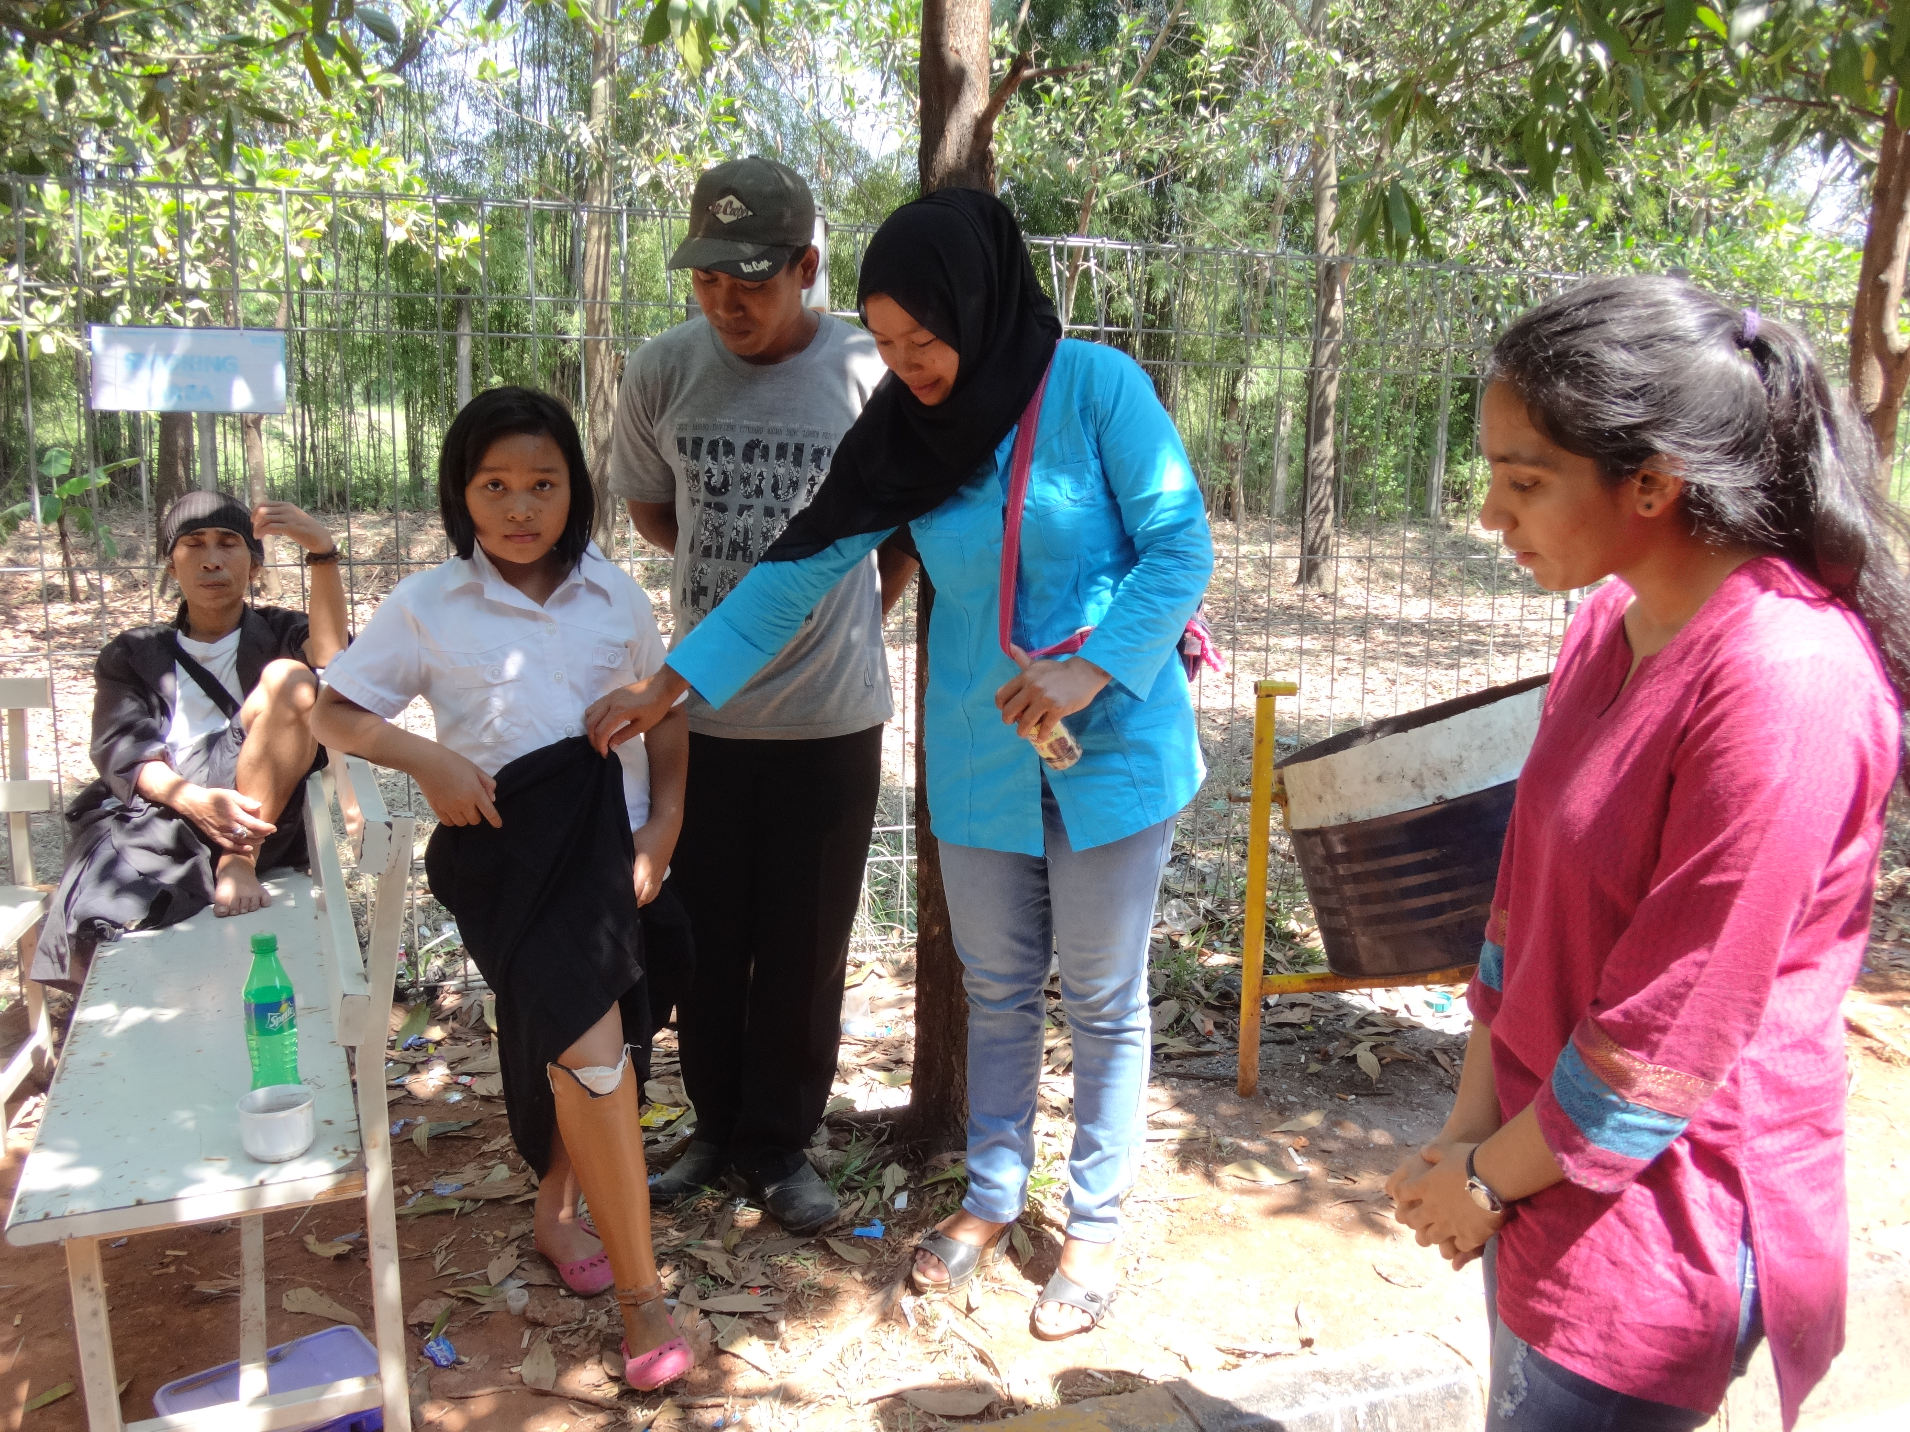
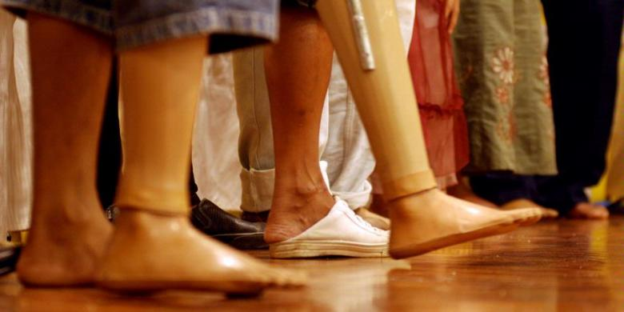


Yayasan Peduli Tuna Daksa
This Yayasan is a subdivision of Yayasan Sadhu Vaswani, which specializes in making and providing prosthetic limbs to those less fortunate and those who are unable to afford them. The Yayasan whilst working with one of the top prosthetic limb producer – The Jaipur Foot produces up to millions of legs, arms, foot etc. Supplying high quality leg to people all over Indonesia.
The Yayasan provides prosthetics to the limbless at free of cost, allowing the people to convert from disabled to abled without the tension of payments.

Limb for the Limbless

Artificial Legs
Mechanical support that can transform a person’s life
The artificial leg is a support that is used by amputees who no longer have a leg(s). The leg gives not only physical stability but also allows the people to gain mental stability – to become more confident and independent. It provides a stepping-stone for the limbless people to achieve their goals. It offers a better quality of life – help patients live fuller and more productive lives than they might have thought otherwise.
What is the Artificial Leg?
  - Saloni Patni
  - Grade 10
  - GMIS
Jln, Agung NIaga IV Blok G5 No.17-19
Sunter Podomoro Jakarta Utara 14350
Telephone – 021-65309156/7
To help the needy people, all you have to
do is donate to Yayasan Peduli Tuna Daksa. Each Leg costs at the most Rp 1.5 million or $100.
You can help by donating to the following
bank account number :
BANK CENTRAL ASIA ( BCA ) KPC.
Pintu Air. Jakarta-Indonesia
1063015150 ( Rupiah A/C )
1063016440 (US $ A/C)
For : YAYASAN PEDULI TUNA DAKSA
Swift code: CENAINDJA

Sumiyati, 9, was an ordinary schoolgirl, who loved to play outdoor games including soccer. On 27th July 2012 while on her way to school, she met with an accident. This tragic event not only left her with a traumatic memory but also left her legless. Luckily she was hospitalized and survived the deadly accident. Yet, she described her life after the accident as ‘miserable’ and ‘devastating.’ She soon realized that she would never be able to play sports with her friends and would never be the same person she was before. She felt alienated and unlike herself. This, her mom defined was the moment her daughter’s self esteem plummeted down. Her once high confidence and independence degraded, and she was not eating or drinking. It was when her mother had received a call from a friend informing her that her daughter could get an artificial leg that was free and provided by Yayasan Peduli Tuna Daksa.
At present, Sumiyati describes her situation much more positively. When she started walking using the artificial leg she felt lively and in control. She was grateful of the organization for being able to let her once again do the things she loved. Her confidence once again established. She revealed that her primal instinct was that she would have no friends and everyone would look at her funny, but instead she was still able to have fun with her friends and was once again a normal human being.
“The smallest act of kindness is worth more than the grandest intention” –Oscar Wilde

HOW CAN YOU HELP?

SUMIYATI’S STORY

“Losing a limb is not their choice, but helping them walk again is definitely ours”

